Home in Space – Potential local habitats built on other planets and habitat spaceships
Technical information

N.b. For reference, we are providing hyperlinks where relevant information supporting our statements can be found in the website of NASA.

1. BUILDING LOCAL HABITATS ON OTHER PLANETS
Available information suggests the presence of many natural local habitats (without the need to build them from scratch) that could potentially be used for life on other planets and celestial bodies, providing habitable conditions were present. Unfortunately, either radiation or gravitation, temperature or strong winds make human life there impossible directly in these structures.

1.1. Materials
The first challenge in building local habitats on other planets is to find building resources there. Let’s compare the basic elements in the chemical composition of concrete on Earth with what is available on other planets.
1.1.1. Concrete as an example:
Concrete is made mostly of oxidized forms of calcium, silicon, aluminum, and iron. Many of these elements are already discovered in the minerals on other planets:
- Silica is abundant in space dust and on rocks on other planets.
- Calcium is abundant in stars and planets, including as big deposits on Mars.
- Iron is confirmed as abundant on Mars, Venus and Mercury.
- Aluminium oxides are found in large quantities in Mars, Neptune and Uranus.
- Ice deposits are currently found on Mars.
- As another big advantage for us, it is already confirmed the presence of pits and cave-like structures on the Moon.

Many other examples of potential construction materials that can be found on other planets and celestial bodies can be added. So, it is obvious that primary sources for building local habitats on other planets and celestial bodies are available: this first challenge for humanity is passed.

1.2. Tools and machines
1.2.1. Building with traditional non-electric tools where habitable conditions are present:
The second challenge in building local habitats on other planets is the use of tools and machines. Here can be used simple tools that can just mix available resources to create mixtures that can be used for directly building local habitats, e.g. bricks from available stones and dust to be made, composites just glued with some chemical resin brought from Earth or even sourced locally and mixed with melted ice, where ice deposits are available.
So, briefly said, on many planets that we will be able to find in the near future, we can suppose that non-electric traditional tools like shovels, molds and others can help us start building, providing that we find habitable conditions. After the “bricks” created with local materials can be dried in craters or caves where available on the surface of the relevant planet. They can be used for the first building structures there.

1.2.2. A project for a machine that can build autonomously on planets with hostile conditions:
For the planets with hostile conditions, we can deploy a machine that can autonomously build there or with minimal human intervention. This machine will be powered by a small mini-reactor and, as alternative options, solar panels that can harness sunlight and turn it into electricity (when and if such sunlight comes to the relevant celestial body). These two types of power units will be connected with the engine of the machine, so that if one of them is out of work, the other will be able to replace it. Alternatively, an electricity storage concrete battery can be available, because if the reactor breaks at night, the energy stored within the battery can keep the machine working.
The second thing is the principle of action of the machine. It will simply vacuum with its electric power and mix within a very big inside container small stones, sand, regolith, resin and melted ice (just as example composites to make the improvised “concrete” for building). In the container, the vacuumed elements will be heated and mixed.
Finally, several pipes will sip the mixture in the forms desired, e.g. a rectangular form for the foundation of the building, etc. The pipes will have valves to open and close when needed, regulating size and quantity of concrete sipped.

Control unit with a CPU regulates the processes. Cooling and circulation systems ensure the temperature inside the machine is within operation range. Cables and pipes complete the systems and ensure connections between the main units of the machine. Ground attachment mechanisms ensure the machine is attached to the ground for not be overturned by the scarce gravitation.
A very raw drawing of the machine is provided below. Due to the limited time of the hackathon, all technical details can be discussed further.

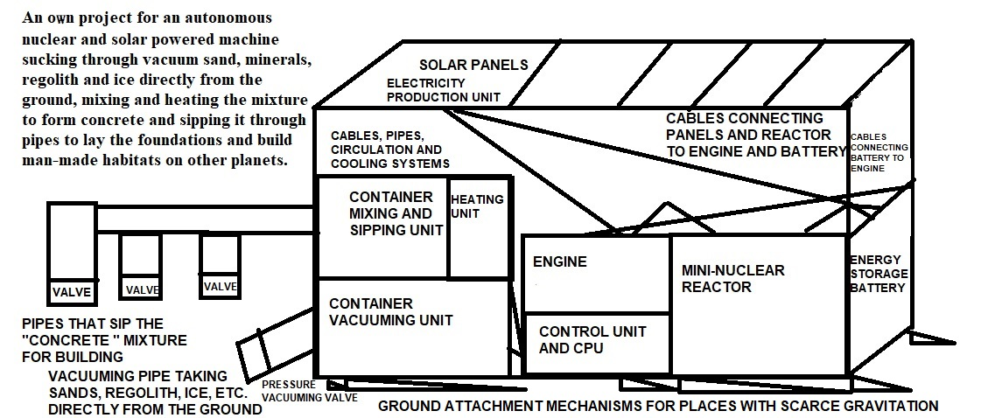
2. BUILDING HABITAT SPACESHIPS FOR LONG-DISTANCE TRAVEL
2.1. A CONCEPT FOR FULLY SELF-SUSTAINING HABITAT SPACESHIPS
Potentially we will need fully self-sustaining habitat spaceships for long-term travel to other habitable celestial bodies and higher speeds for the space rockets and space stations: it can be done only through constant abundant fuel production in the travelling construction itself and optimal use of space in the ship.
Choice of fuel and type of engine – based on xenon (propellant only), uranium (electric engine plus electricity for the habitat), hydrogen, solar panels or other types – is crucial for creating long-term man-made habitats able to travel (and spend some time landed) for years; nuclear power is one of the most feasible – also risky – ways for constant regular production of energy that can be used to sustain long-distance travels, so potential mini-reactors and similar installations can be used as super-engines for spaceships and stations (options like solar panels can complement the power of these engines as well).
Enough energy produced in the spaceship itself opens a big chance for food production there in greenhouses, extracting water from atmosphere (condensation) if found any around space bodies while travelling; optimization of space in the spaceships is crucial for less fuel use: pliable furniture like beds-tables, chairs-cupboards, etc., can help much and ensure crew can travel for years.
A very raw drawing of the habitat spaceship is provided below. Due to the limited time of the hackathon, all technical details can be discussed further.
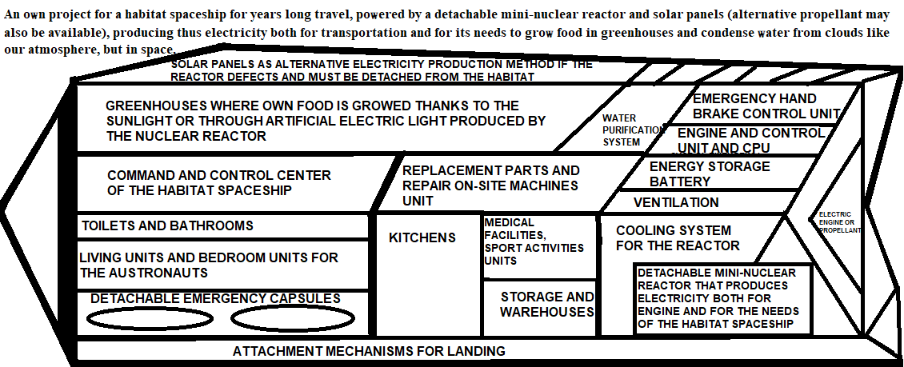
Authors:
Setara Lima Wahdat,
Rahila Lima Wahdat
and Dr. Stoyna Georgieva Wahdat
Contacts:
Dr. Stoyna Wahdat
stoynawahdat@abv.bg
00359 886 52 30 87.
References:
- Aluminum-bearing site on Mars draws NASA visitor (no date) NASA. Available at: https://www.jpl.nasa.gov/news/aluminum-bearing-site-on-mars-draws-nasa-visitor/ (Accessed: 04 October 2025).
- Curiosity finds calcium-rich deposits - NASA science (2024) NASA. Available at: https://science.nasa.gov/resource/curiosity-finds-calcium-rich-deposits/#:~:text=NASA’s%20Curiosity%20rover%20finds%20calcium,in%20cracks%20and%20rock%20fractures. (Accessed: 04 October 2025).
- High-silica ‘Lamoose’ rock - NASA science (2024) NASA. Available at: https://science.nasa.gov/resource/high-silica-lamoose-rock/#:~:text=A%20rock%20fragment%20dubbed%20%22Lamoose,(July%2011%2C%202015). (Accessed: 04 October 2025).
- NASA is locating ice on Mars with this new map (2024) NASA. Available at: https://www.nasa.gov/solar-system/planets/mars/nasa-is-locating-ice-on-mars-with-this-new-map/ (Accessed: 05 October 2025).
- New evidence adds to findings hinting at network of Caves on Moon - NASA Science (2025) NASA. Available at: https://science.nasa.gov/solar-system/new-evidence-adds-to-findings-hinting-at-network-of-caves-on-moon/ (Accessed: 05 October 2025).
- Nuclear propulsion could help get humans to Mars faster (2024) NASA. Available at: https://www.nasa.gov/solar-system/nuclear-propulsion-could-help-get-humans-to-mars-faster/ (Accessed: 04 October 2025).

New evidence adds to findings hinting at network of Caves on Moon - NASA Science (2025) NASA. Available at: https://science.nasa.gov/solar-system/new-evidence-adds-to-findings-hinting-at-network-of-caves-on-moon/ (Accessed: 04 October 2025).
High-silica ‘Lamoose’ rock - NASA science (2024) NASA. Available at: https://science.nasa.gov/resource/high-silica-lamoose-rock/#:~:text=A%20rock%20fragment%20dubbed%20%22Lamoose,(July%2011%2C%202015). (Accessed: 04 October 2025).
Curiosity finds calcium-rich deposits - NASA science (2024) NASA. Available at: https://science.nasa.gov/resource/curiosity-finds-calcium-rich-deposits/#:~:text=NASA’s%20Curiosity%20rover%20finds%20calcium,in%20cracks%20and%20rock%20fractures. (Accessed: 04 October 2025).
Nuclear propulsion could help get humans to Mars faster (2024) NASA. Available at: https://www.nasa.gov/solar-system/nuclear-propulsion-could-help-get-humans-to-mars-faster/ (Accessed: 04 October 2025).
Aluminum-bearing site on Mars draws NASA visitor (no date) NASA. Available at: https://www.jpl.nasa.gov/news/aluminum-bearing-site-on-mars-draws-nasa-visitor/ (Accessed: 04 October 2025).
NASA is locating ice on Mars with this new map (2024) NASA. Available at: https://www.nasa.gov/solar-system/planets/mars/nasa-is-locating-ice-on-mars-with-this-new-map/ (Accessed: 05 October 2025).
New evidence adds to findings hinting at network of Caves on Moon - NASA Science (2025) NASA. Available at: https://science.nasa.gov/solar-system/new-evidence-adds-to-findings-hinting-at-network-of-caves-on-moon/ (Accessed: 05 October 2025).

